
THE LIGHTHOUSE

Newsletter for December 2016

While I am in the world, I am the light of the world."
John 9:5

Message from Our Pastor

Dear Sisters and Brothers in Christ,

Advent, it seems to have become the lost and forgotten church season. It has gotten lost in the rush of the good Christmas deals and all the rest of trappings of the commercialization of Christmas. Yet it is an important time in the life of the Christian church, especially in the times we are living in where fear, polarization, and gloom and doom seem to have a grip many aspects of our lives.
The season of Advent is about reflection, in the lessons we will hear in next four Sunday’s in December, we will hear about Hope, Peace, Joy and Love. The focus of those four words will be on a baby, a Savior, a Redeemer, the Prince of Peace our Emanuel. Yet we know the rest of that story, the baby grew, he taught us, and loved us in our brokenness and what he did for us on the Cross is the most precious gift we will ever receive, forgiveness and eternal life and a relationship with God, the only one who can truly give us and work through us, Hope, Peace, Joy and Love.
There is something special happening in our community of faith, something that embodies those four words and the season of Advent. I see a Sunday School growing with more children every week, I see the same with the Bible and book studies at both Zion and Trinity. I see families getting together for family fun night at the end of the month. I see the Sisters of Zion and the NOIZ group sharing with each other and those in the community outside of our church walls the relationship Christ so deeply wants for each of us to have for one and other. I see it in the wonderful gifts the church has received in the last few months!
The prayers we have been praying for our community of faith are working! I see it and feel it, so keep praying for one and other and reflect this Advent season on the Hope, Joy, Peace and Love that our Lord and Savior Jesus Christ has given us, and go out and proclaim it to a world that so desperately needs it, and invite them to join us in these wonderful gifts.
May your Christmas be filled with safe travels and the blessings of Hope, Peace, Joy and Love.

Yours in Christ,
Pastor David

Newsletter

The December Newsletter was adopted by
Ray and Shari Baron



Noisy Offering

The noisy offering for December 4th will go to the Mackinac County Children’s Toy Drive.

Advent

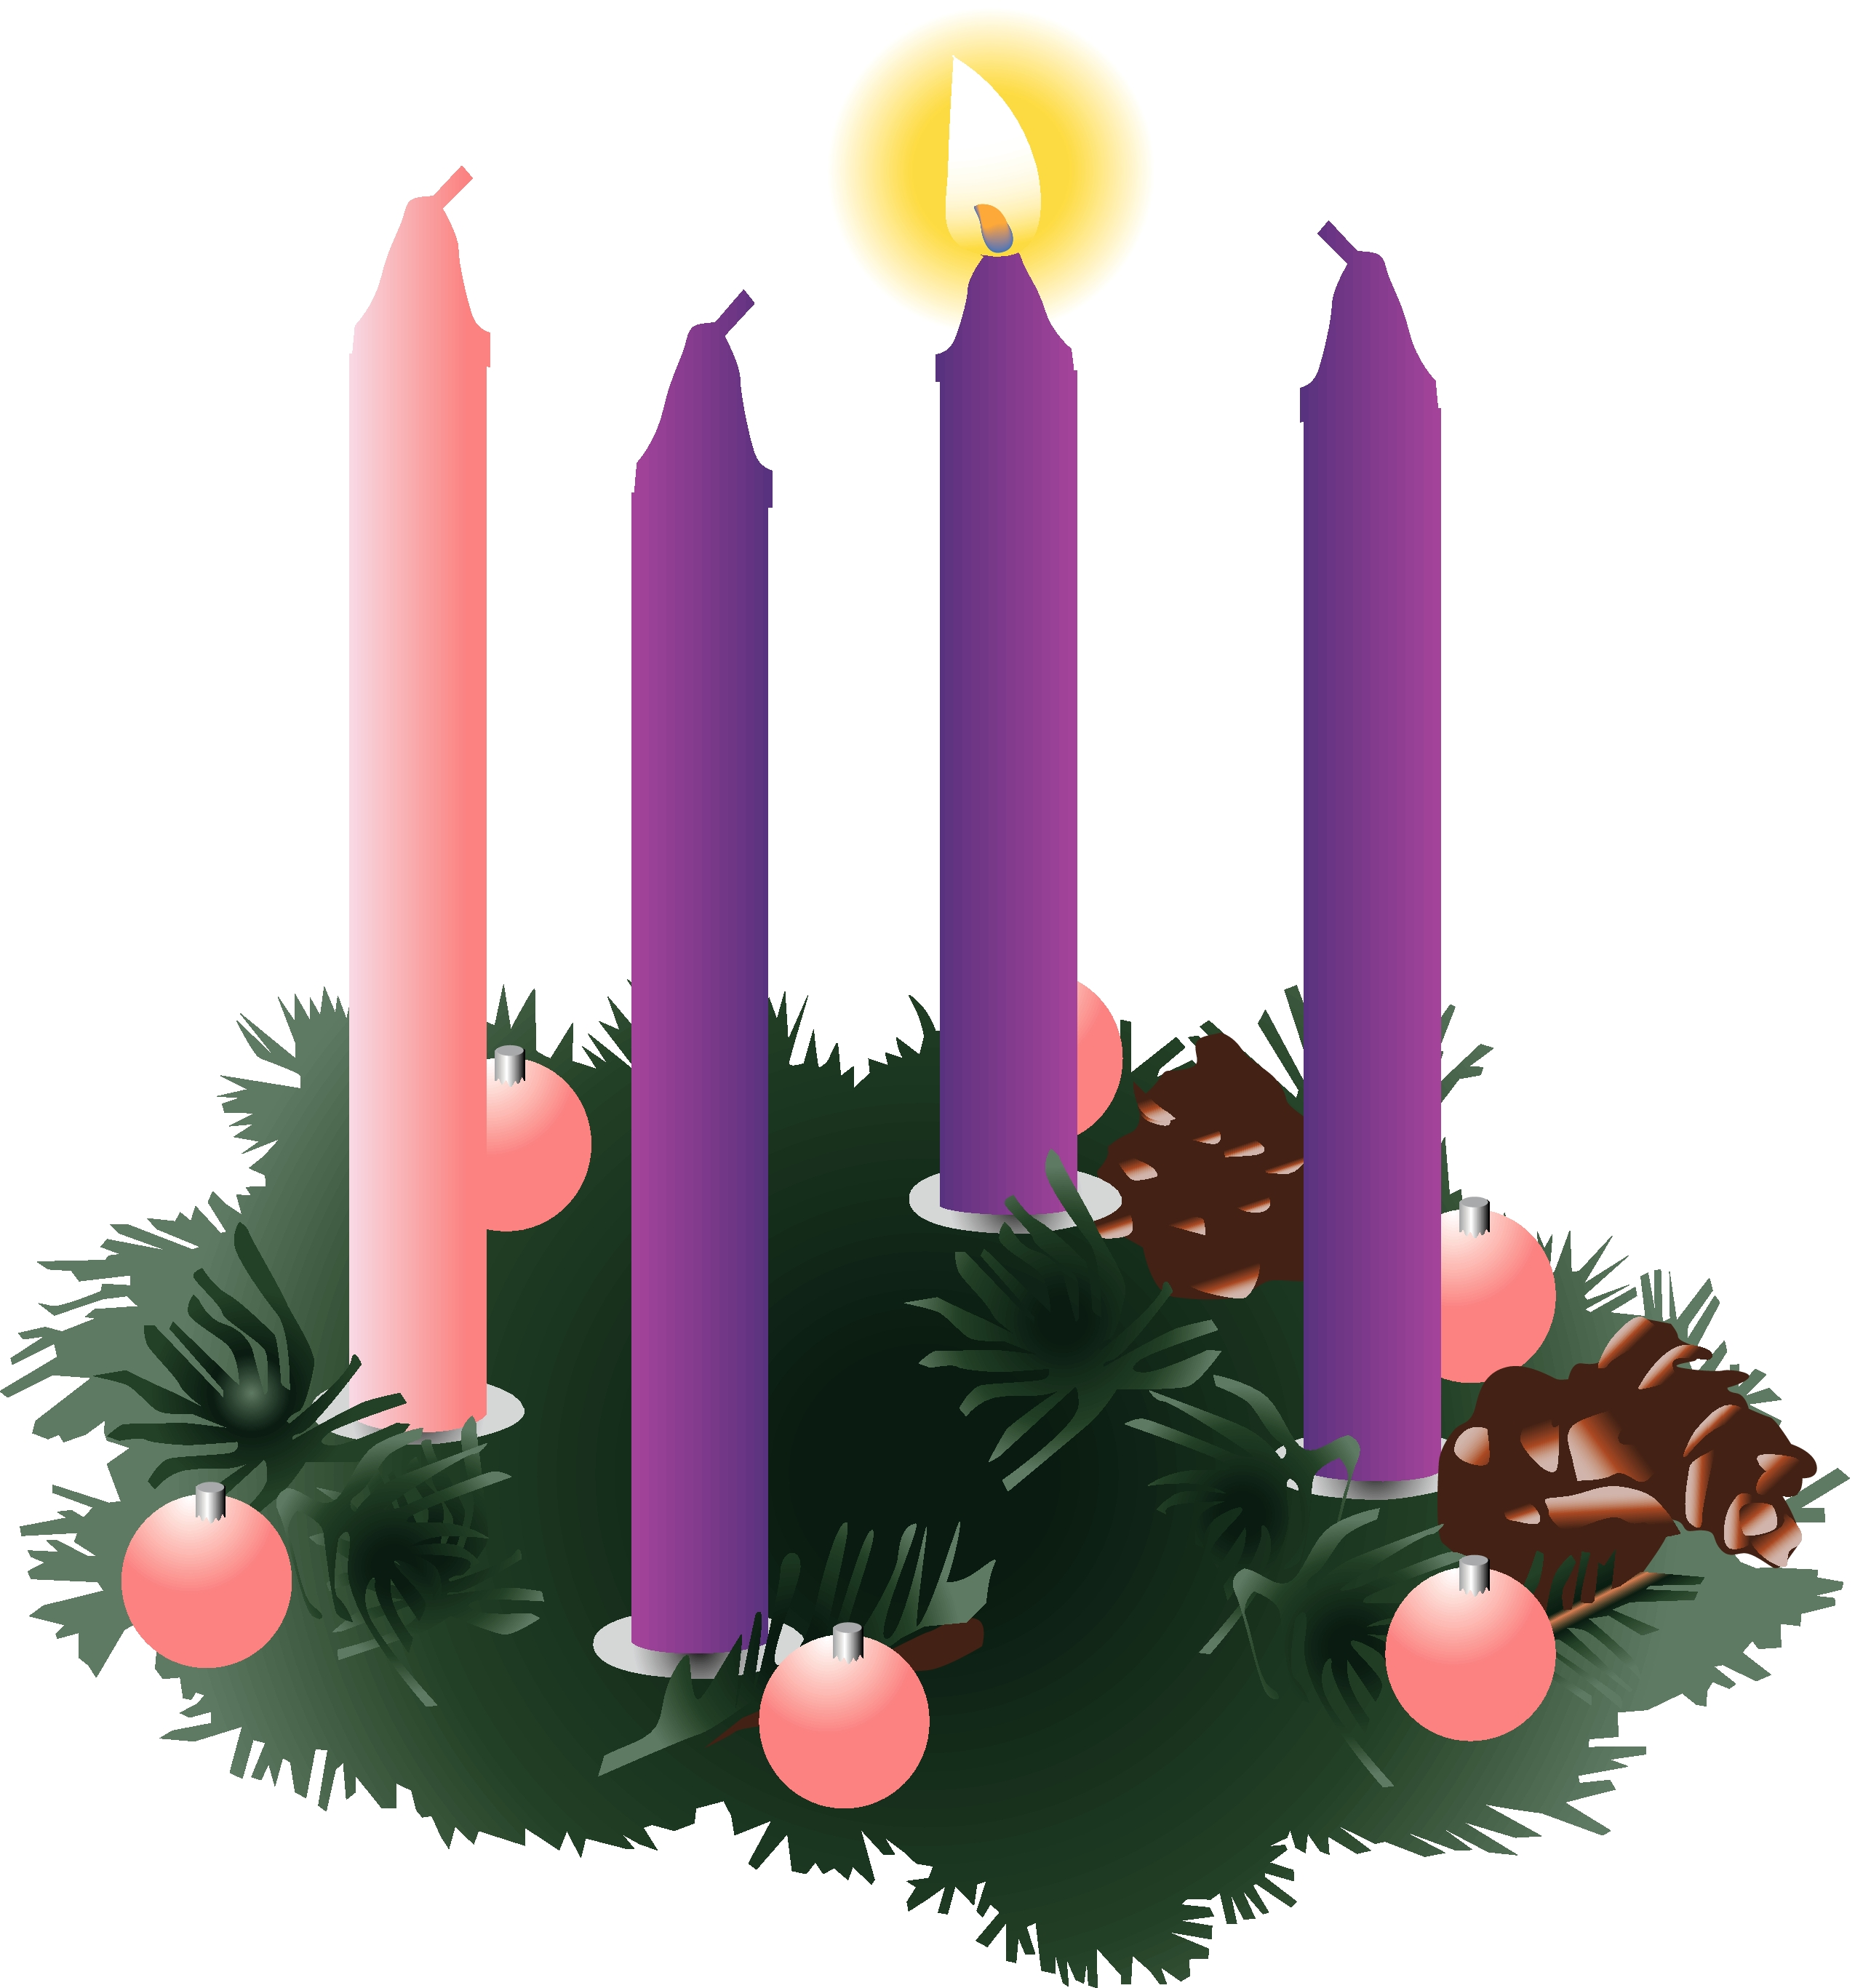
Advent began November 27th! Advent is a time to focus inward and prepare our hearts and lives for Christ. This is the countdown and earnest waiting for the Messiah. Please take some time during this season to:

- Worship weekly
- Pray daily
- Read your Bible daily
- Practice generosity

Sunday School

We will have Sunday School for all children, Preschool – 5th grade, during the 11 am service at Zion (except for the last Sunday of the month).

Trinity Christmas Dinner

Join us on Saturday, December 3rd for Trinity’s Fourth Annual Christmas Dinner. Appetizers at 5 pm, dinner at 6 pm.

Craft Show


On December 4th Zion will be hosting a Craft & Vendor Show, 1 – 5 pm. Come and find great Christmas gifts!

NOIZ

The NOIZ Youth Group selling hotdogs, pop corn, and hot chocolate, etc. at the craft show on December 4th to raise money for their Youth Gathering in Houston.

Adult Bible Study

Adult Bible Study at Trinity will be most Tuesdays at 6 pm.

Adult Bible Study at Zion will be most Wednesdays at 7 pm. Please join us in the Zion Family Center!

Confirmation Meeting

Confirmation will be on the 2nd Sunday of each month from 5 – 7 pm. This month will be on December 11th.

Food Pantry/Area Hope

During the month of December Zion will be collecting food cans for the Food Pantry. During the winter months, the need always increases.

Longest Night Healing Service

On Wednesday, December 21st, in concert with the United Methodist Church, we will have a Healing Service at Zion at 7 pm.
Christmas Services

Join us as we celebrate the birth of our Savior on Christmas Eve. Trinity will meet at 5 p.m. and Zion at 8:00 p.m.
There will be no service on Christmas Day.

Spartan Labels


We are stillcollecting Spartan Labels to raise money for Zion. Collect the UPC labels from any Spartan product and bring them to the church. We only need 160 labels to reach 1000.

Poinsettias

Anyone wishing to order poinsettias for the
Christmas Eve service, can contact Betsy Turf at
906-643-1512 by December 11th. Cost is $11.75
for red, white or red & white.

Help!

We are looking for someone who can replace the canlight bulbs over the alter and organ in front of the church. You will probably need scaffolding or a really tall ladder. If you can gift this to your church, it would be appreciated. Thanks, Your Family in Christ.

Pasties

We still have pasties for sale at Zion. $5 @
Prayer List

(If you would like someone added to the prayer list, please call or email the church)

Mary Belonga, Dave & Lois Movalson, LaTaunya Paquin, Barb Lehto, Charlie Lamoreaux, Ed Idalski, Luanne Keinonen, Joel Morabito, Judy Schlehuber Bridges, Jackie Rippit, Tom & Taffy Coffey, Ed Heenan, Bev Kammers, Eric Rose, Charles Beeck, Phillip Brooks, Joe & Sharon Chalmers, Joanne Tamlyn, Bethany Wiese, Nadine Dandona, Patty Thibault, Jim Rose, Gayle Kaminsky Pande, Alfie Dyer, Christine Scott, Charlie Dowd, Virginia Gustafson, Rick Brown, Karen Fowler, Danielle Becker, Delores Marshall, Rod Novenske, Corina Clark, Bill & Sandy Tielbar, Gladys Pope, Russell Winberg, Cindy Hendricks, Linda Wilkins, Bill Anderson, Rick, and Kirk

Anniversaries in December

December 1 Dave & Lois Movalson
December 10 Jim & Jerri Rose
December 28 Tim & Sally Idalski

Birthdays in December

December 2 Andrea Insley
4 Bonnie Bergeron
- Joyce Gustafson
- Josh LaJoice
- Sue St. Onge
12 Trudy Olsen
14 Bill Harju
15 Tonya Winberg
17 Phil Schaeffer
20 Robby Olsen
22 Sally Idalski
23 Chase DeKeyser
24 Carol Elmblad
24 Toby Ferguson
25 Robert Marshall
26 Lorraine Graham
29 Barb Wilkins
30 Mike Lehto

Baptismal Anniversaries

December 2 Madison Olsen
3 Kelly LaJoice
7 Zoey Stenson
9 Brad Therrian
15 Rita LaVake
15 Connie Olsen
19 Joshua Feleppa
20 Lana Lennington
20 Sue St. Onge
24 Bernard Crouch
24 Katti Gamble
24 Alicia Garen
24 Cole Garen

25 Jordan Caldwell
27 Dawn Akers
27 Lucas Hammond
27 Brent Ruff
27 Jayce Ruff
27 Drew Stockero
28 Kristine Vallier
29 Barb Wilkins
30 Max Coburn

Contact Information

Pastor David Tielbar may be reached at 906-984-2051 or at david.tielbar6@gmail.com. In an emergency, you can reach the Pastor’s cell phone at (563) 880-4512

Church telephone: 906-643-7870 - Answering machine
The secretary will usually be in the office on Tuesday and Thursday mornings from 9 – 12

To email the church is: ziontrinity950@yahoo.com
The website is at http://zionstignace.com/home.html
- Find us on facebook at www.facebook.com/zionstignace

Zion Evangelical Lutheran Church and Trinity Lutheran Church are congregations of the Northern Great Lakes Synod and the Evangelical Lutheran Church in America.

Trinity’s Sunday Service is at 9 a.m.
Zion’s Sunday Service is at 11 a.m.

Trinity Worship Families

Dec 4 Kennedy Family
Dec 11 Movalson Family
Dec 18 Baron Family
Dec 24 Chalmers Family

Zion Funeral Committee December-March

Team Leader: Lana Lennington (643-6576)
Co-leader: Marlene Olsen (643-9519)

Servants for Zion

Ushers & Greeters
Dec 4 Jerry & Susan Fenlon
Dec 11 Martha Sjogren & Donna Harju
Dec 18 Confirmation Youth
Dec 24 Lana Lennington Family

Lectors
Dec 4 Betsy Turf
Dec 11 Dawn Akers
Dec 18 Rita LaVake
Dec 24 Lynn Evans

Acolytes
Dec 4 Matthew Valletta
Dec 11 Josh Feleppa
Dec 18 Brendan Insley
Dec 24 Ellie Tielbar

Communion Assistants
Dec 4 Jerry Fenlon
Dec 11 Mary Christiansen
Dec 18 Paul Shepard
Dec 24 Lana Lennington

Altar: Cathie Tielbar
Money Counters: Donna Harju & Martha Sjogren

The Usher duties are:
- Arrive 30 minutes before church
- Pass out bulletins and welcome guests
- Help with the offering and communion
- Record attendance

Council Meetings

Trinity Council – 6 pm, December 13th
Zion Council – 6:30 pm, December 14th

Zion’s Council Members
President: Lana Lennington 643-6576
Vice-President Paul Shepard 984-2069
Co-Treasurers: Dawn Akers 643-7552
Co-Treasurers: Lana Lennington 643-6576
Secretary: Steve Christiansen 298-1051
Mary Christiansen 235-6123
Jerry Fenlon 643-8730
Tim Idalski 643-6574
Karen Schlehuber 643-0311

Trinity’s Council Members
President: Jerri Rose 292-5570
Vice-President Tracy Movalson 292-5581
Secretary: Sharon Chalmers 292-5440
Treasurer: Pega Kennedy 292-5633
Co-Treasurer: Jim Rose 292-5570
Financial Secretary: Tom Gustafson 292-5460
WELCA: Pega Kennedy 292-5633
John Kennedy 292-5633
Lois Movalson 292-5581

Treasurer's Report for Zion
January 1, 2016 through November 12, 2016
Income:
 | Amazon Smile Foundation | 15.45
 | Building | $ 1,200.00
 | Church Use Income | $ 491.00
 | General | $ 68,154.65
 | Pasty Sales | $ 1,263.00
 | Thrivent Financial Income | $ 44.00
 | Trinity Share | $ 13,091.61
 | TOTAL |  | $ 84,259.71
Expenses:
 | Administration | $ 5,064.11
 | Benevolence | $ 1,823.78
 | Church Maintenance | $ 10,984.59
 | Education | $ 265.78
 | Parsonage Maintenance | $ 2,683.86
 | Pastoral | $ 52,682.69
 | Worship | $ 4,692.06
 | --To Building Fund | $ 1,180.00
 |  |  | $ 79,376.87
 |  |  | 4,882.84
***********************************************************
Thrivent Financial Investment Fund |  |  | $ 288.07
General fund balance: |  |  | $ 4,225.05
Kitchen/Building Fund balance |  |  | $ 2,047.19
General fund owes building fund: |  |  | $ 20.00
General fund owes Mission Endowment fund: |  |  | $ 7,995.00
Zion Lutheran Church Council Meeting
November 16, 2016

Council Members Present: Pastor Dave, Mary, Karen, Jerry, Steve, Lana, Dawn.

Meeting was called to order at 6:35.

Pastor Dave opened with devotions from 1 Peter v.6.

1. Pastor's Report:

A. Theology Education that Pastor Dave attended went well.

B. Pastor is looking for a subcommittee to promote evangelism to get "our name" out to a broader community. Exploring options make our building more open to the community and other outreach ideas. Council is planning a days retreat in January to further develop some ideas to pursue different options.

C. Zion will have Christmas Eve services at 8 p.m. on Saturday December 24. There will be no service on Sunday, December 25.

2. Treasurer's Report:
Treasurer's report was discussed and approved.

3. Secretary's Report:
Secretary's report was reviewed and approved.

4. Old Business:

A. We have had donors who offered to fund the elevator repair! Jerry has received a repair estimate of $1,150 and has arranged for Great Lakes Elevator to make the repair on their next trip to the U.P.

5. New Business:

A. Gluten free communion wafers are now available for those needing them.

B. Several lights in the church basement are not working. Council is working on getting them fixed.

C. Next Council meeting is December 14 at 6:30 p.m.

Meeting adjourned with LORD'S Prayer.

Respectfully submitted,
Steve Christiansen

Annual Christmas Musicale


Come enjoy the music at the
55th Annual Christmas Musicale
at the United Methodist Church
on December 4th at 6:30 pm.
Presented in honor of
Karen Fowler.

Straits Area Cantata

Sunday, December 11th at 2 pm at St. Anthony’s Catholic Church in Mackinaw City.

Xmas Bazaar

December 3rd from Noon until 6 pm at the Moose Lodge.
Craft vendors and food (burger baskets). Public welcome!

Evergreen Living Center Craft Show

There will be an Evergreen Living Center Resident Craft Show at the hospital to raise money for their Activities Department. Monday, December 12th, 9 am to 5 pm. Get some Christmas shopping done while helping a great cause.

Feeding America

The Mobile Food Pantry with be at LaSalle High School on December 14th from 11 am until 1 pm (or the food runs out).
Fruits, vegetables, dairy products and baked goods.

HOPE Chest

The new winter HOPE Chest hours are:
Fri - Mon: Closed
Tues: 10am - 4pm *donation drop-offs 10-4
Wed: Noon - 6pm *donation drop-offs Noon-5
Thurs: 10am - 4pm *donation drop-offs 10-4
Volunteers are needed! Please consider giving of your time and talent to our mission. Our volunteers are vital to the success of the HOPE Chest. There is a wide range of volunteer positions available, during open hours and on Wednesday evenings from 6 - 8 pm to stock shelves.



Wishing You a Blessed Christmas!

